Name-Ujjawal Mandhani
Batch-F6
Enroll No.-9918103237
OSSP Lab 3

Question 1:Write a Linux C programme to create two processesP1 and P2. P1 takes a string andpasses it to P2. P2 concatenates the received stringwith another string without usingstring function and sends it back to P1 for printing.

#include <stdio.h>
#include <stdlib.h>
#include <unistd.h>
#include <sys/types.h>
#include <string.h>
#include <sys/wait.h>

int main()
{

int fd2[2], fd1[2];
char fixed_str[] = " Mandhani";
char input_str[100];
pid_t p;

if (pipe(fd1) == -1)
{
fprintf(stderr, "Pipe Failed");
return 1;
}
if (pipe(fd2) == -1)
{
fprintf(stderr, "Pipe Failed");
return 1;
}

scanf("%s", input_str);
p = fork();

if (p < 0)
{
fprintf(stderr, "fork Failed");
return 1;
}
else if (p > 0)
{
char concat_str[100];

close(fd1[0]);

write(fd1[1], input_str, strlen(input_str) + 1);
close(fd1[1]);
wait(NULL);
close(fd2[1]);
read(fd2[0], concat_str, 100);
printf("Concatenated string %s\n", concat_str);
close(fd2[0]);
}
else
{
close(fd1[1]);

char concat_str[100];
read(fd1[0], concat_str, 100);

int k = strlen(concat_str);
int i;
for (i = 0; i < strlen(fixed_str); i++)
concat_str[k++] = fixed_str[i];

concat_str[k] = '\0';

close(fd1[0]);
close(fd2[0]);

write(fd2[1], concat_str, strlen(concat_str) + 1);
close(fd2[1]);
exit(0);
}
}
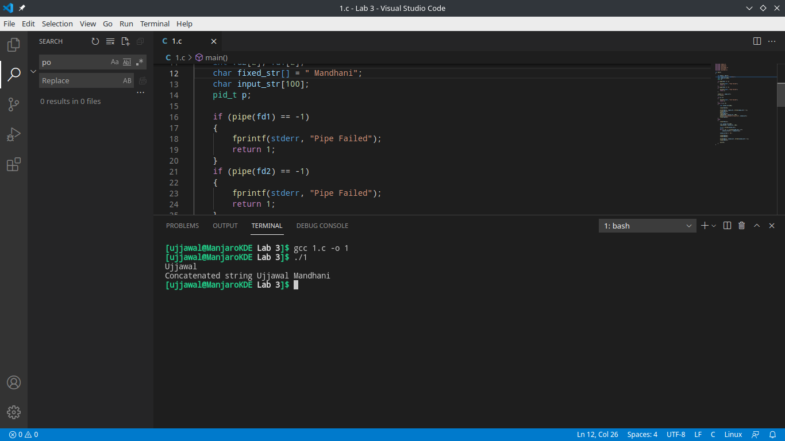

Question 2:What is the output of the following code?

#include <stdio.h>
#include <stdlib.h>
#include <unistd.h>
#include <sys/types.h>
#include <string.h>
#include <sys/wait.h>

int main()
{
if (fork())
{
if (!fork())
{
printf("1\n");
}
else
{
printf("2\n");
}
}
else
{
printf("3\n");
}
printf("4\n");
return 0;
}

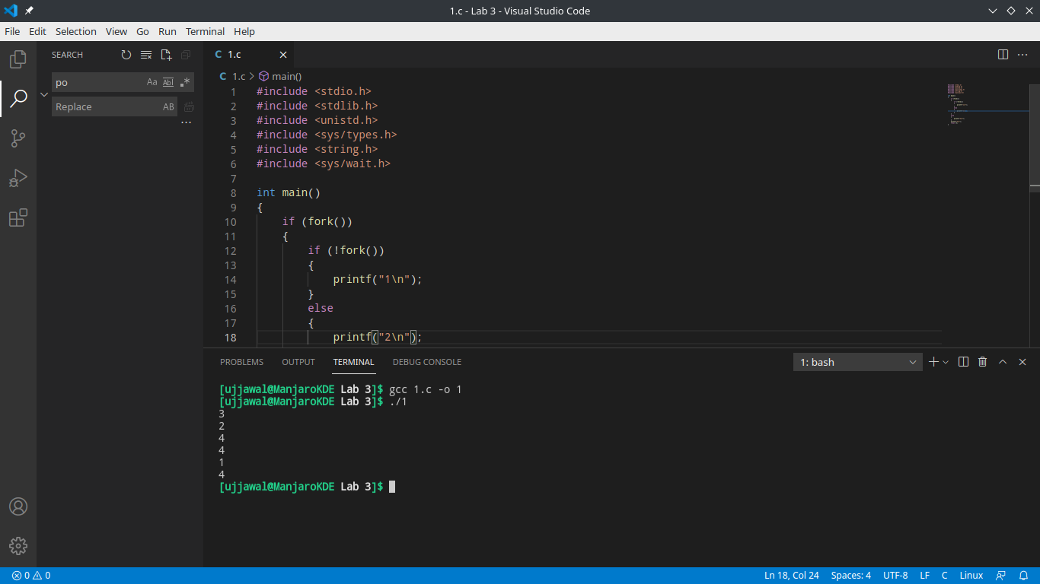
Question 3:Write a program which acts like a timer; It asksthe user for a specific time, allowsthe user to execute other programs while it waitsand pops up with an alert onfinishing the time.

#include <stdio.h>
#include <stdlib.h>
#include <unistd.h>
#include <sys/wait.h>
int main()
{
int n;
printf("Enter The Time in Second to wait a process: ");
scanf("%d", &n);
int p = fork();
if (p == 0)
{
sleep(n);
printf("sleep Time is over\n");
printf("I am child ,I can't wait,but i cansleep \n");
}
else
{
printf("I am parent ,I can wait but if child sleepI can excute my self\n");
}
}

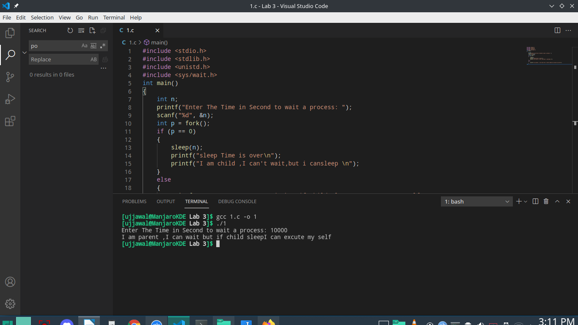

Question 4:Create a file named my file.txt that contains thefollowing four lines :
Child 1 reads this line
Child 2 reads this line
Child 3 reads this line
Child 4 reads this line
Write a C program that forks four other processes.After forking the parent process goes intowait state and waits for the children to finish theirexecution. Each child process reads a linefrom the file my file.txt ( Child 1 reads line 1,child 2 reads line 2, child 3 reads line 3 andchild 4 reads line 4 ) and each prints the respectiveline. The lines can be printed in any order.

#include <stdio.h>
#include <stdlib.h>
#include <unistd.h>
#include <sys/wait.h>
int main()
{
char c[100][100];
FILE *fptr = fopen("myfile.txt", "r3");
for (int i = 0; i < 4; i++)
{
char ch = getc(fptr);
for (int j = 0; ch != '\n'; j++)
{
c[i][j] = ch;
ch = getc(fptr);
}
}
fclose(fptr);
if (fork() == 0)
{
printf("%s\n", c[0]);
if (fork() == 0)
{
printf("%s\n", c[1]);
}
else
{
wait(NULL);
printf("%s\n", c[2]);
}
}
else
{
wait(NULL);
printf("%s\n", c[3]);
}
}

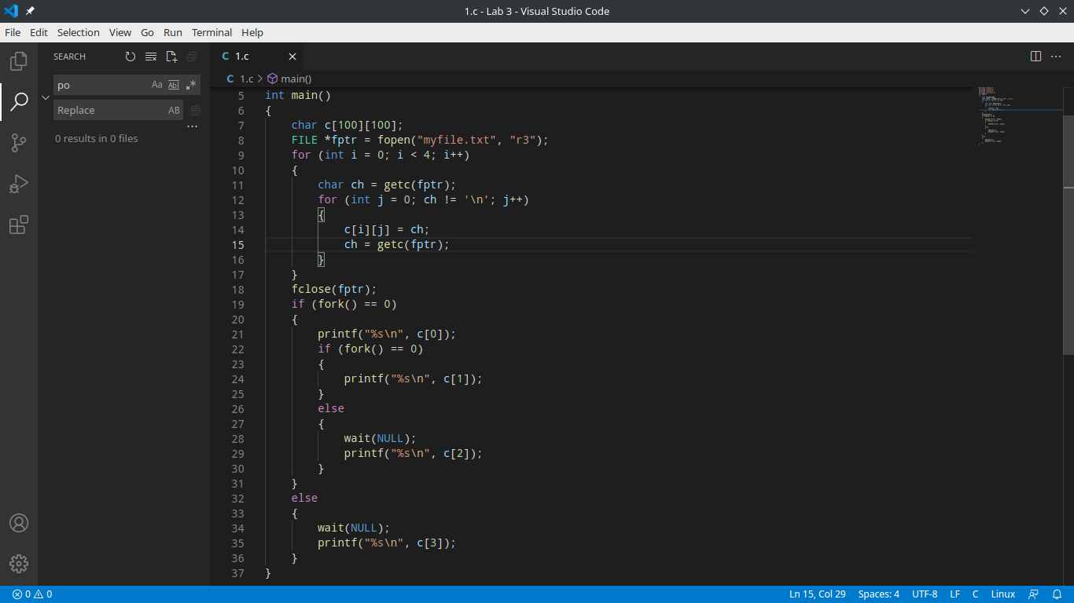
Question 5:. Write C program in Linux operating systems for implementing the first come firstserve scheduling algorithm

#include <stdio.h>
void findWaitingTime(int processes[], int n, int bt[], int wt[])
{
wt[0] = 0;
for (int i = 1; i < n; i++)
wt[i] = bt[i - 1] + wt[i - 1];
}
void findTurnAroundTime(int processes[], int n, int bt[], int wt[], int tat[])
{
for (int i = 0; i < n; i++)
tat[i] = bt[i] + wt[i];
}
void findavgTime(int processes[], int n, int bt[])
{
int wt[n], tat[n], total_wt = 0, total_tat = 0;
findWaitingTime(processes, n, bt, wt);
findTurnAroundTime(processes, n, bt, wt, tat);
printf("Processes Burst time Waiting time Turnaround time\n");
for (int i = 0; i < n; i++)
{
total_wt = total_wt + wt[i];
total_tat = total_tat + tat[i];
printf(" %d ", (i + 1));
printf(" %d ", bt[i]);
printf(" %d", wt[i]);
printf(" %d\n", tat[i]);
}
int s = (float)total_wt / (float)n;
int t = (float)total_tat / (float)n;
printf("Average waiting time = %d", s);
printf("\n");
printf("Average turn around time = %d ", t);
}
int main()
{
int processes[] = {1, 2, 3};
int n = sizeof processes / sizeof processes[0];
int burst_time[] = {10, 5, 8};
findavgTime(processes, n, burst_time);
return 0;
}

